Cyclic Redundancy Check

Abstract:

This report presents a detailed analysis and implementation of the cyclic redundancy checking (CRC) algorithm, a widely used technique for detecting errors in digital networks and storage devices. This project focuses on designing an efficient CRC algorithm, analyzing its performance, and exploring its applicability in ensuring data integrity during transmission.

Introduction:

In the field of digital communications and data storage, ensuring the integrity of transmitted or stored data is crucial. One of the most widespread and effective methods for detecting errors in digital data is cyclic redundancy checking (CRC). CRC is a powerful type of checksum that calculates an integer value, based on the binary representation of the data, to detect accidental changes in raw data. The CRC algorithm originated in the field of digital signal processing, and is a key component of many data transmission protocols and storage systems due to its simplicity and effectiveness in detecting common errors caused by noise in transmission channels.

The goal of this project is to implement the CRC algorithm in Java, demonstrating its effectiveness in detecting errors. This report explains the algorithmic approach taken, delves into the coding process, and discusses the testing methodologies used. The implementation focuses on improving the algorithm in terms of speed and reliability, making it suitable for real-world applications where data integrity is critical. Through this project, insights into the algorithm's behavior in different scenarios and its reliability in detecting different types of errors are gained, demonstrating its indispensability in the field of digital communications.

Subsequent sections of this report will detail the implementation methodology, present the results obtained, and provide a comprehensive analysis of the results. The report aims not only to showcase the implementation of the CRC algorithm, but also to enhance understanding of its role and efficiency in detecting errors in digital data transmission and storage.

Methodology:

The methodology for implementing the Cyclic Redundancy Check (CRC) algorithm involves several key steps, each designed to ensure the accuracy and efficiency .

Selection of CRC Algorithm

Algorithm Choice: The CRC algorithm variant used in this project is CRC-32, chosen for its widespread use and strong error-detection capabilities.

Polynomial Selection: The polynomial used for this CRC-32 implementation is 0x04C11DB7, a commonly used polynomial in many standard applications like Ethernet, MPEG-2, and PNG.

Programming Environment and Tools

Programming Language: The implementation is done in [java], chosen for its [reasons, such as efficiency, ease of use, library support].

Development Environment: The coding is carried out using [intelj].

XOR Operation in CRC

One of the core operations in the Cyclic Redundancy Check (CRC) algorithm is the XOR (Exclusive OR) operation. XOR is a bitwise operation that takes two bits and returns 1 if the bits are different, and 0 if they are the same. This simple yet powerful operation is the basis for the division process in the CRC algorithm.

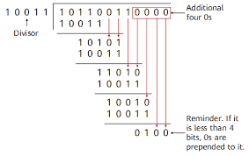

Role of XOR in CRC

Division Mechanism: In CRC, the data to be checked is divided by a predetermined polynomial. This division is not a typical arithmetic division but is carried out using the XOR operation.

Error Detection: By applying the XOR operation between the data bits and the bits of the CRC polynomial, CRC identifies inconsistencies which signal errors in the data.

Simplicity and Efficiency: The XOR operation is computationally simpler and faster than standard arithmetic operations, making it ideal for real-time error checking in digital systems.

Frame Check Sequence (FCS)

The Frame Check Sequence (FCS) is the result of the CRC computation. It is appended to the data before transmission or storage. The FCS is essentially the remainder of the division process carried out by the CRC algorithm.

Generating the FCS

Appending Zeros: Initially, a series of zeros (equal to the length of the CRC polynomial minus one) are appended to the end of the data. This is to make space for the FCS.

CRC Computation: The augmented data is then subjected to the CRC algorithm, which involves the division of the data by the CRC polynomial using the XOR operation.

Extraction of FCS: The remainder of this division, which is the FCS, is then appended to the original data.

Usage of FCS

Transmission/Storage: The data along with the FCS is transmitted or stored. The FCS travels with the data, acting as a checksum.

Validation: Upon retrieval or reception, the CRC algorithm is reapplied to the data with the FCS. If the data is error-free, the result of this computation should be zero, indicating that no corruption occurred.

Importance in Error Detection

High Detection Capability: The combination of the XOR operation and the FCS in CRC allows for a high probability of detecting errors, especially common types such as bit flips and missing bits.

Versatility: The method is versatile and can be adapted for different data lengths and error detection requirements by changing the CRC polynomial.

Result:

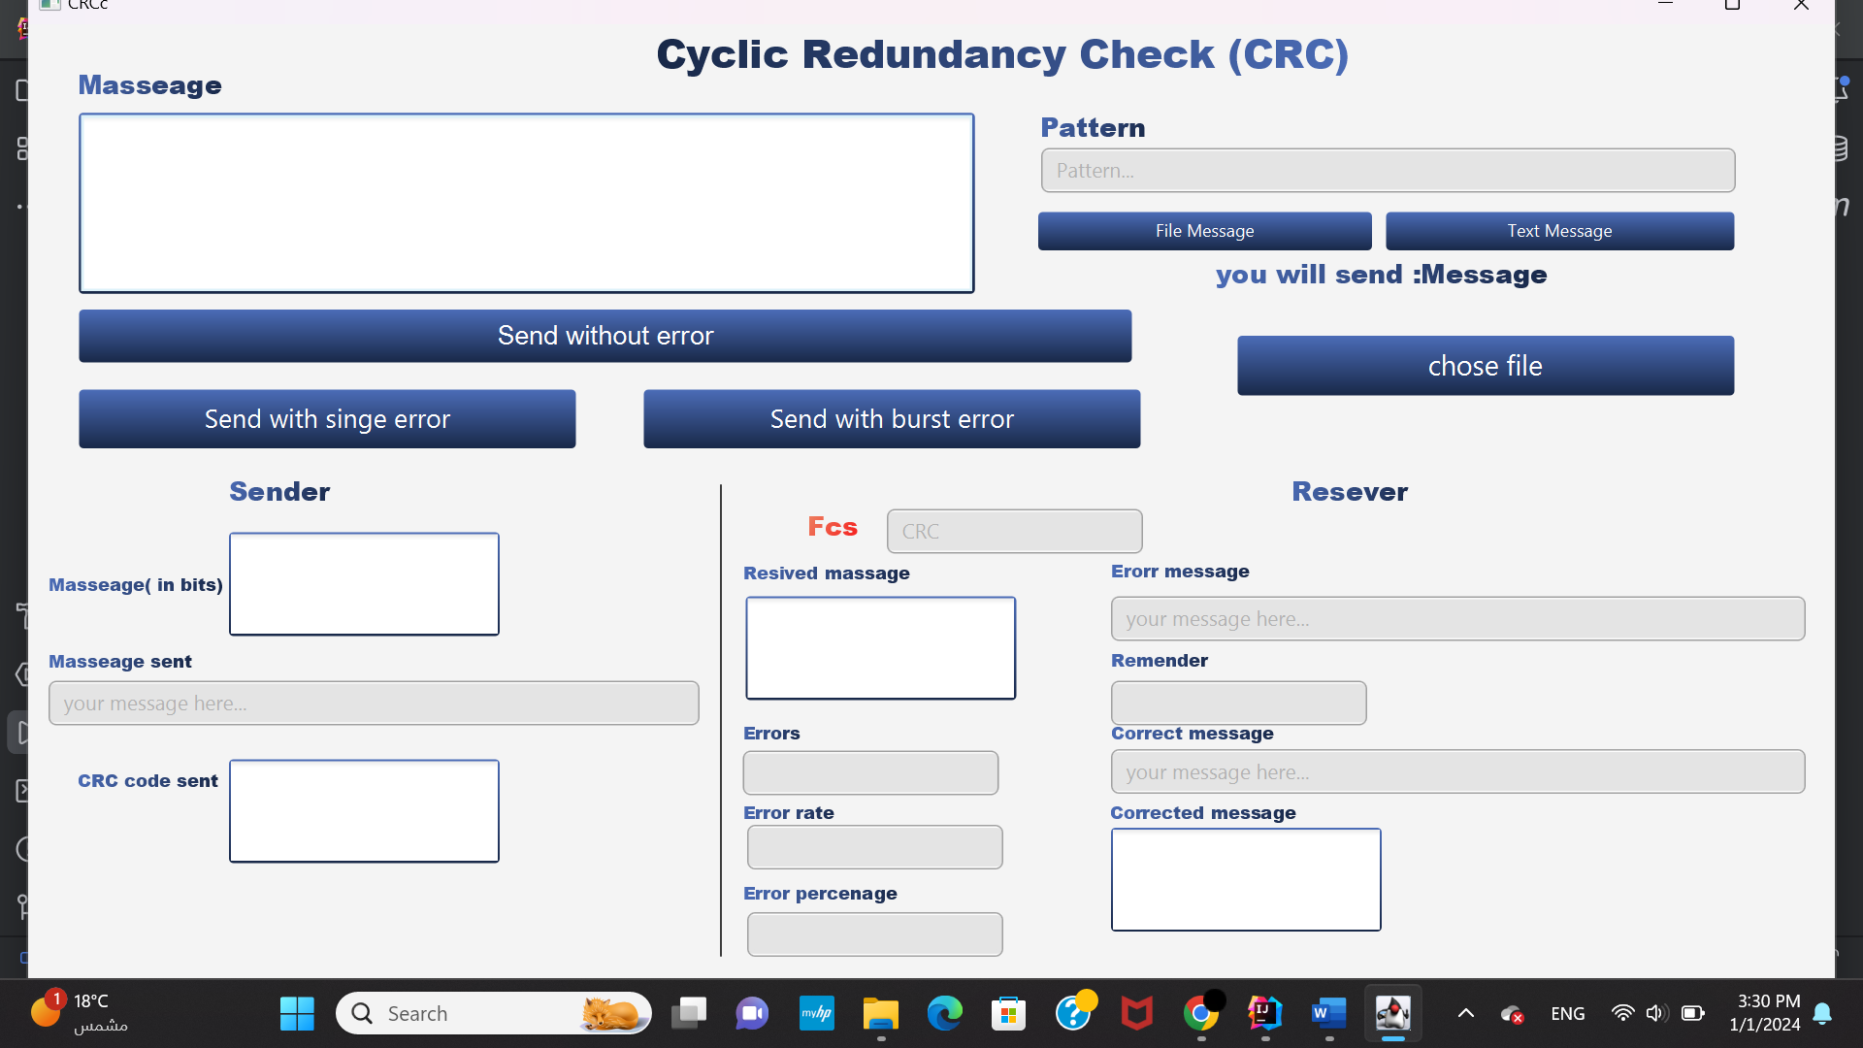

This is the final result of this project and will test It now :

1)Send message:

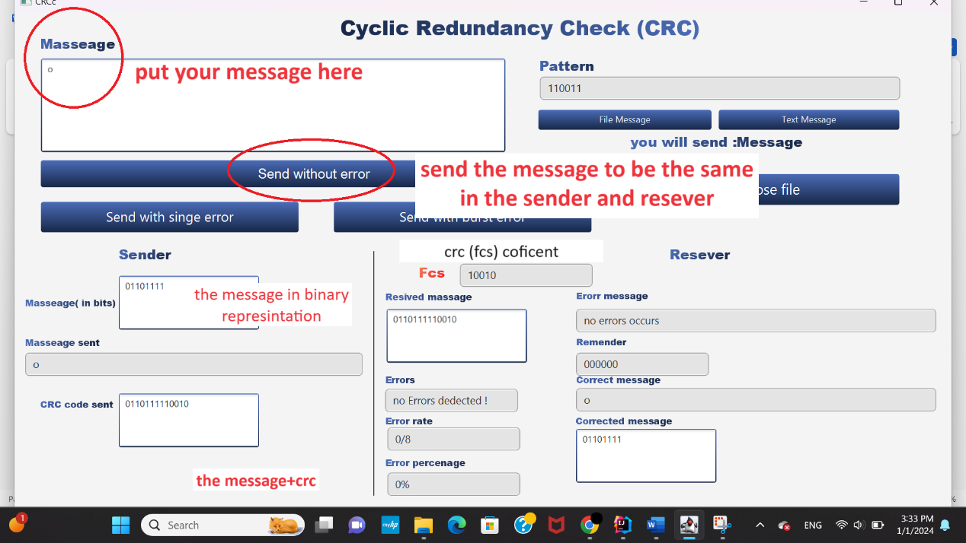

2)with single error:

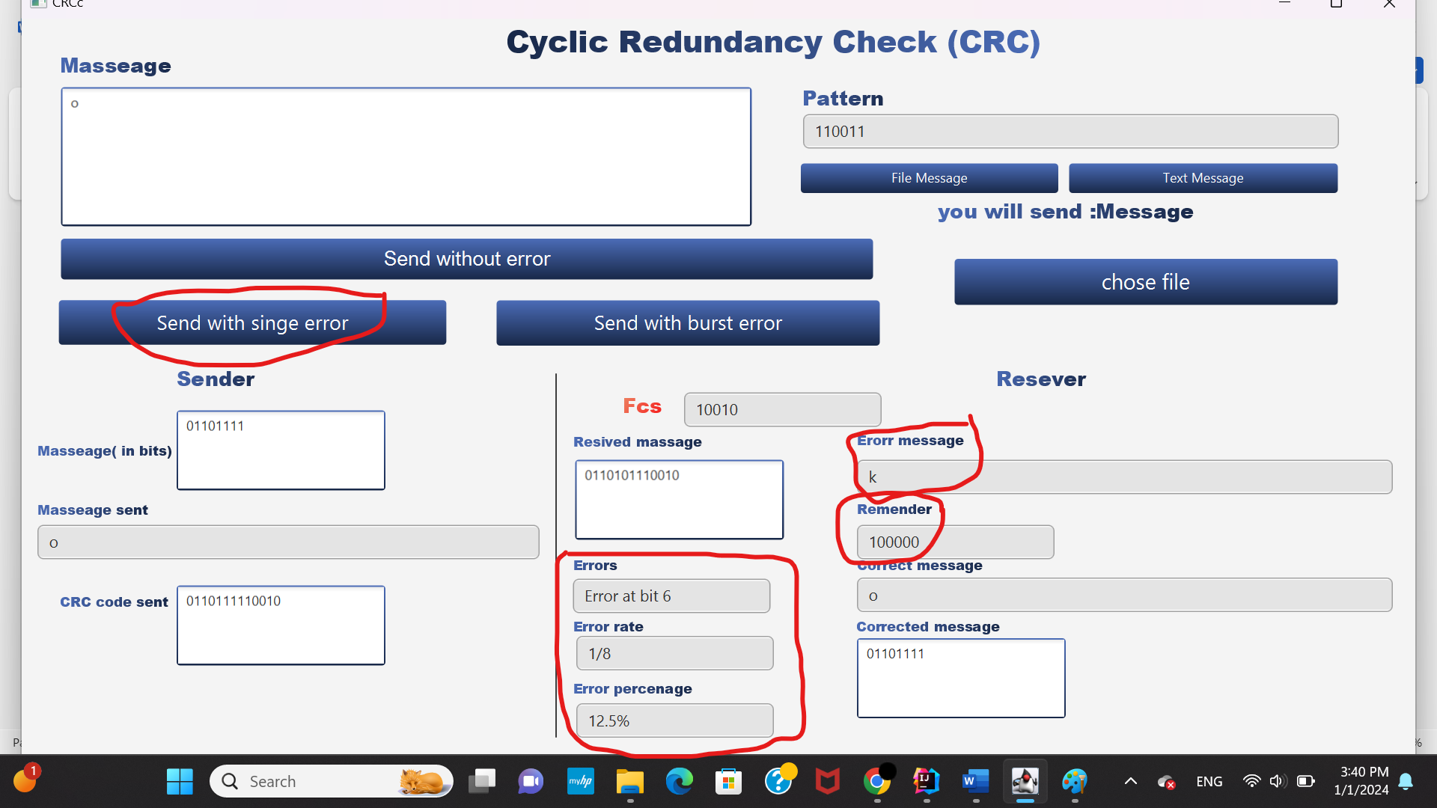

3) tall message with burst error:

Try1:

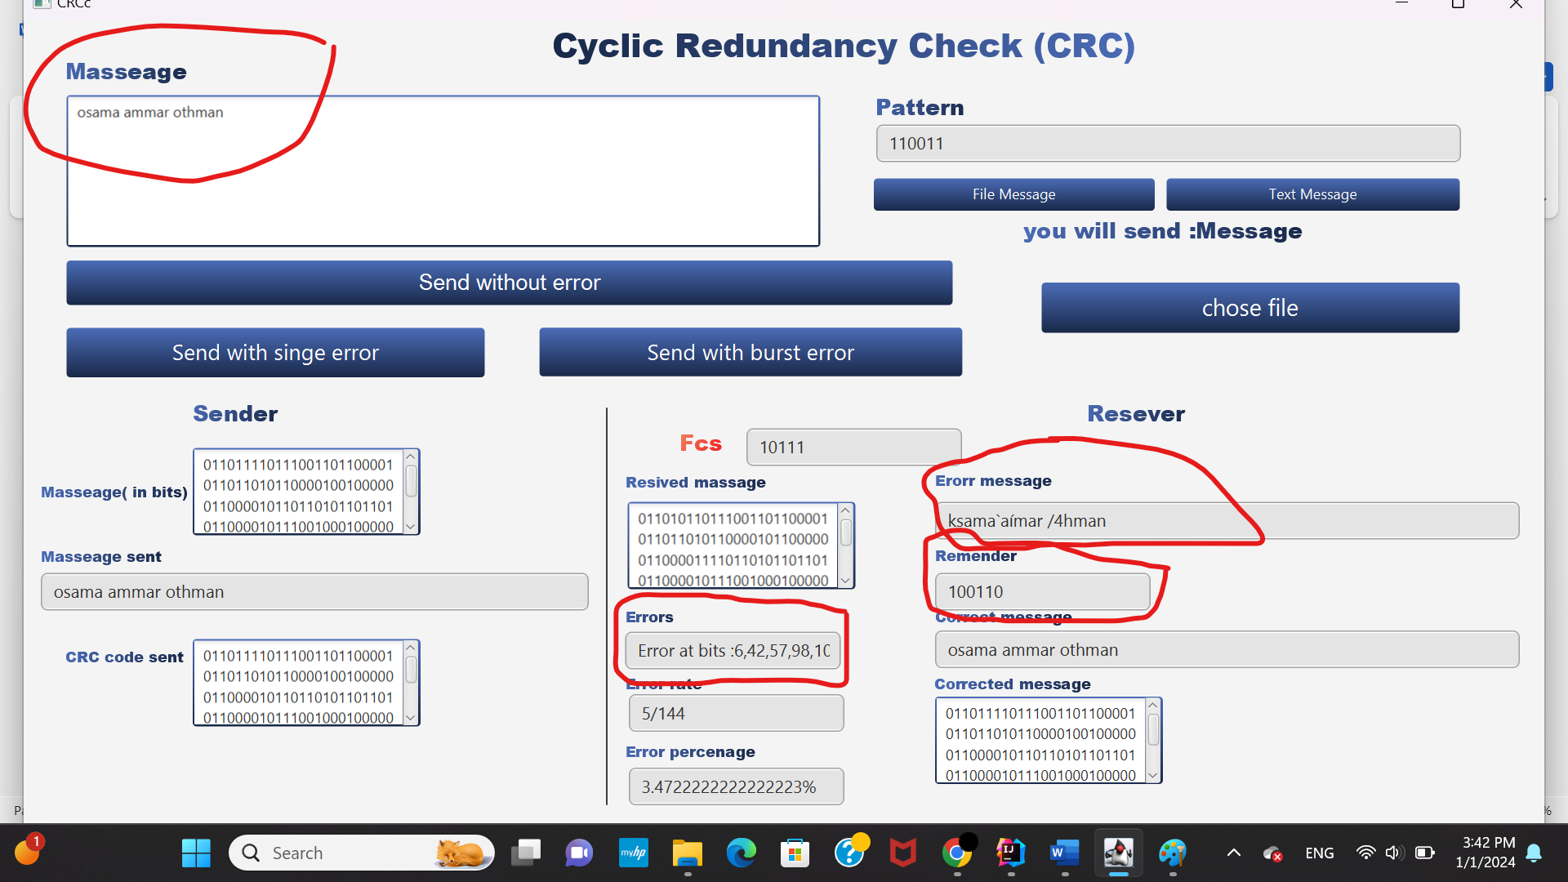

Try2: 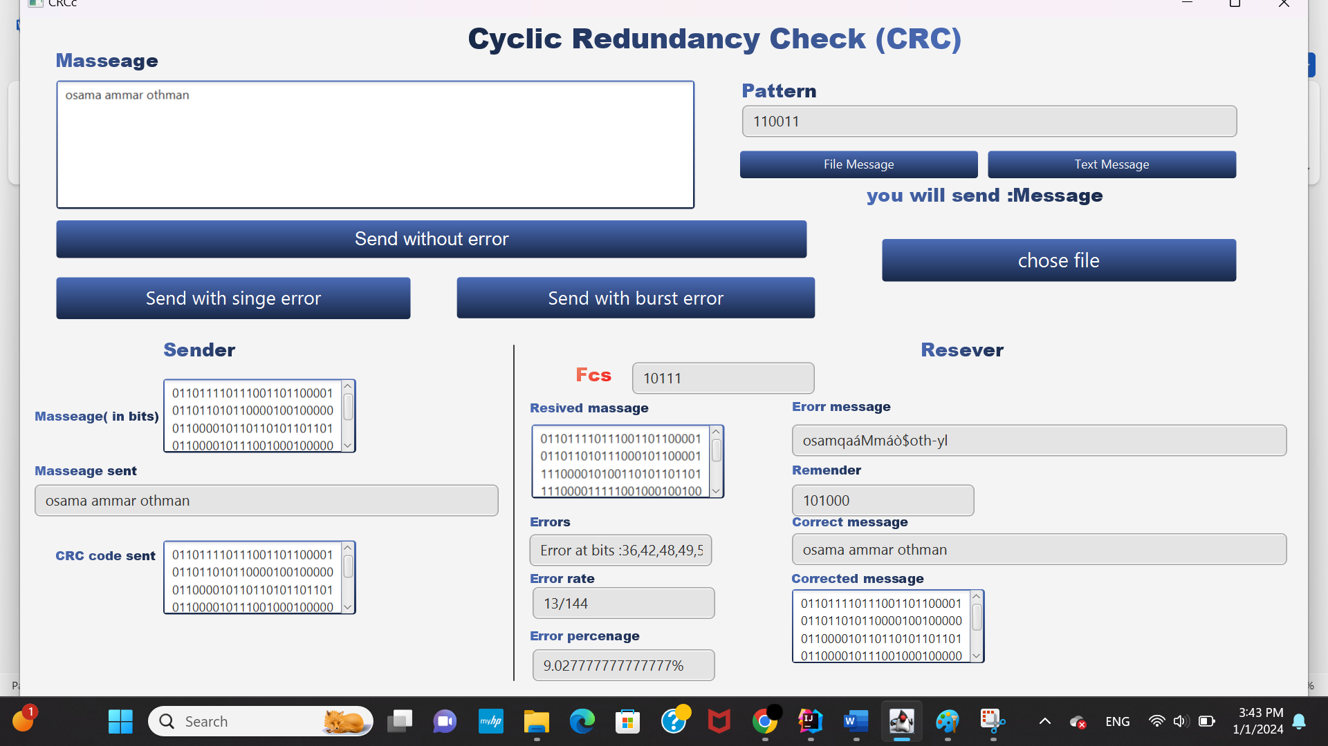

now lets test files :

1)file input   
chose this small file for test 

Send with one error :

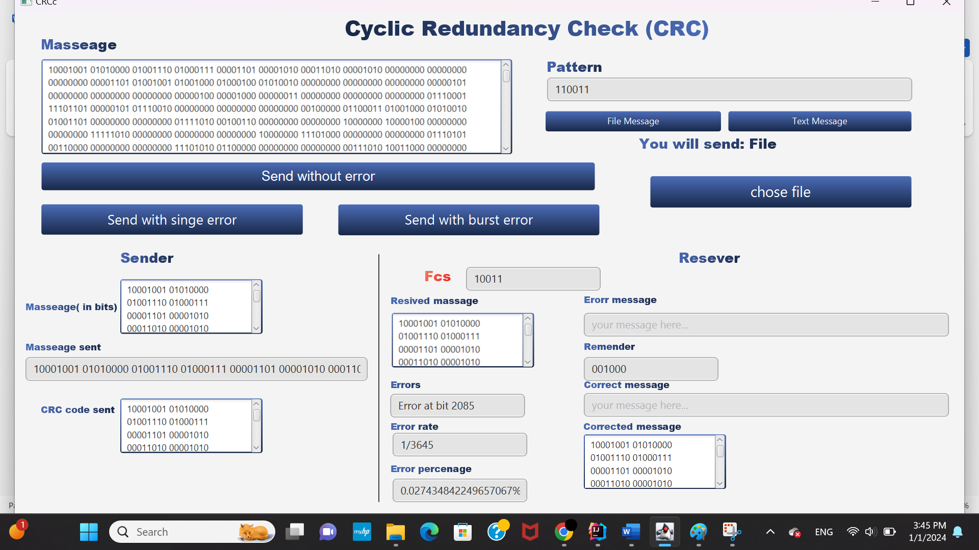

Send with burst error:

